**Instruction for Preparing Camera-ready Manuscripts for**

**Extended Abstract of CIF 21 (14 points, Bold)**

Names of Authors1, Xxxx Xxxx1* and Xxxx Xxxx2 (12 point)

1 Affiliation and Address (12 point)

2 Department of Xxxxxxx, Xxxxxxx Institute of Science and Technology, Chitose 066-8655, Japan

e-address@corresponding.author.ac.jp

Papers should be written in English.

Your manuscript must be prepared on A4 (21 x 29.6) paper. Use the following guidelines in establishing your margins:

Top margin 3 cm

Bottom margin 3 cm

Left margin 3 cm

Right margin 3 cm

The content should be in 12 point, single space and single column. Type the text only within the text area. Everything on the page must fit within the text area, including tables, figures, and captions. Serif (Roman) typefaces, such as Times, are easier to read than sans serif typefaces, such as Helvetica.

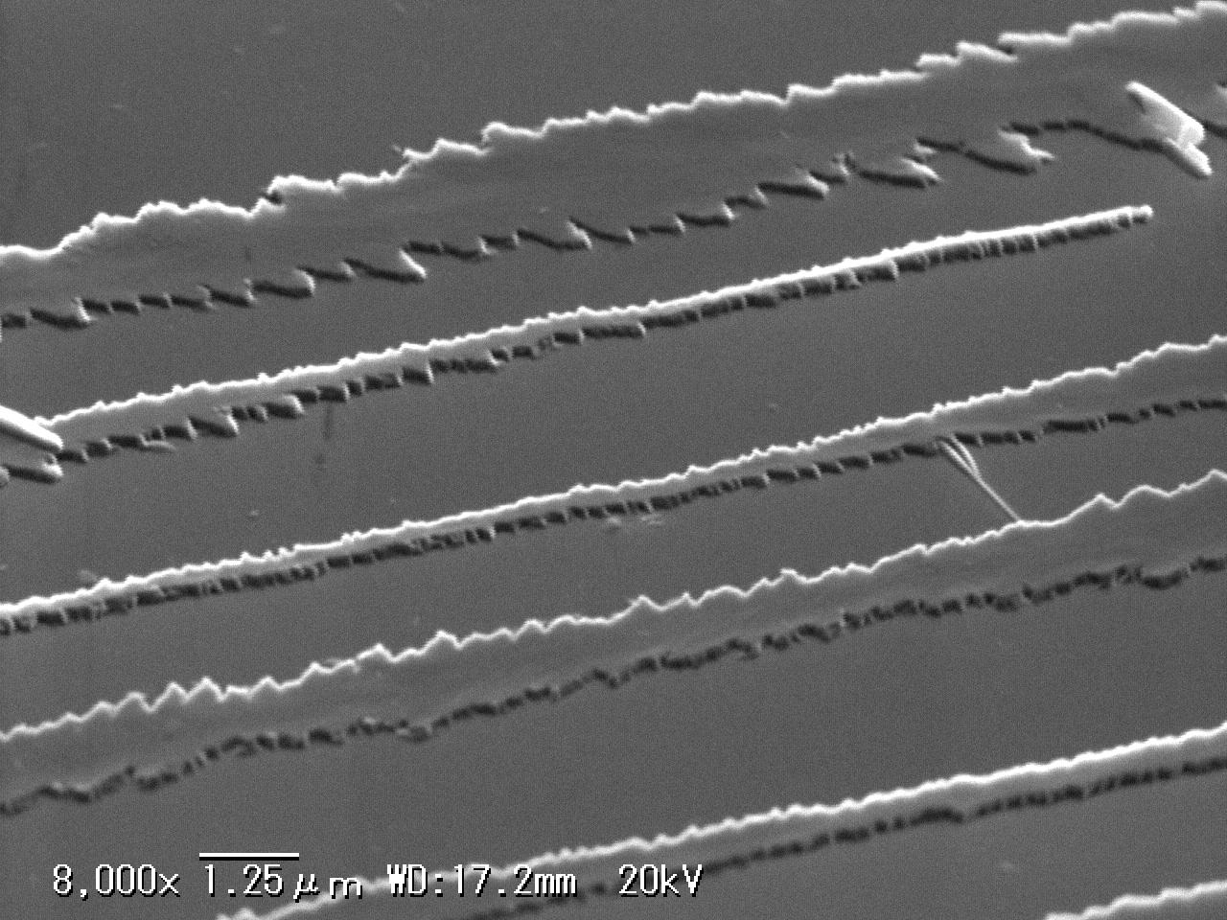 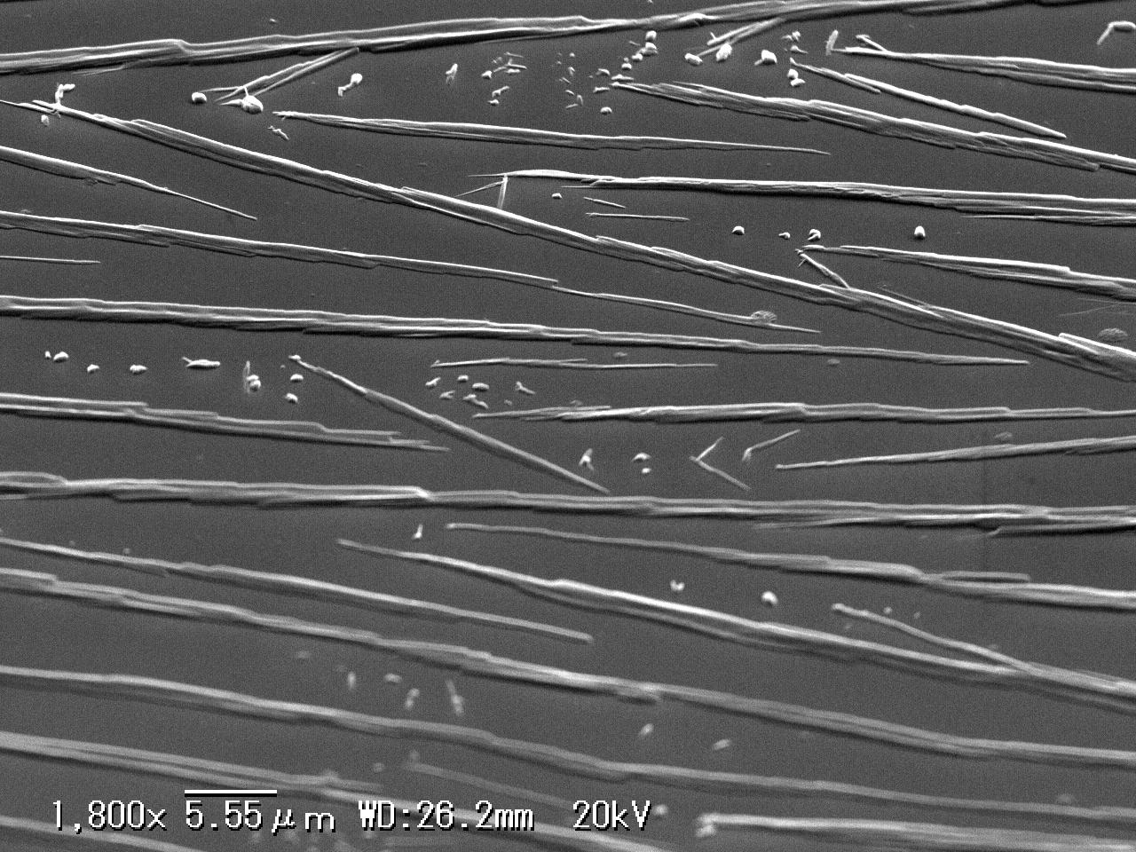

**Figure 1.** xxxx (left) and yyyyy (right)

References

1 A. Aaaa, B. Bbbb, C. Cccc, *J. Abc. Defg*. **10**, 1000-1010 (2010).

2 A. Aaaa, B. Bbbb, P. Q. Pppp, *Xyz. PPq Rev.*. **9**, 090003 (2009).